CHEM 330 02- Biological Chemistry- 1S 2024
Exam #3

Name………………………………………………………………………………………………………………………

A) Multiple Choice section. Only one correct option. 2.5 points each. 1.5 minutes each.

1) How many isoprene units are present in the terpene molecule shown below?

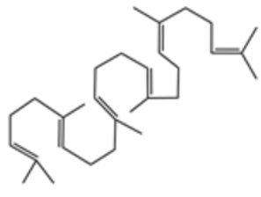
A) 2
B) 3
C) 1
D) 8
E) 5
F) 6

2) What is the name of the lipid shown below?

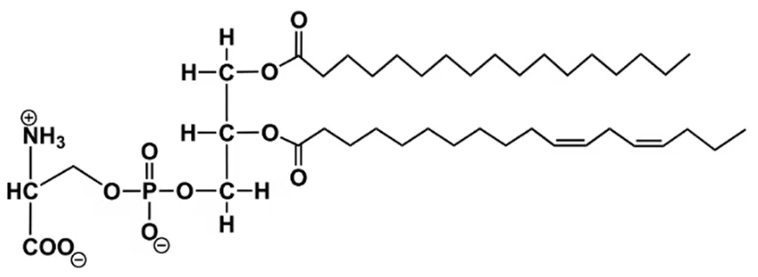
- Phosphatidylglycerol
- Phosphatidylethanolamine
- Sphingomyelin
- Phosphatidylserine
- Phosphatidic Acid

3) Which part of a glycerophospholipid is hydrophobic?

A) Phosphate group
B) Fatty acid tails
C) Glycerol backbone
D) Polar head group

4) The hydropathy plot below shows the hydrophobicity of a protein along its amino acid sequence. Positive values indicate hydrophobic regions, while negative values indicate hydrophilic regions. Based on the plot, which of the following best describes the structure or localization of this protein?
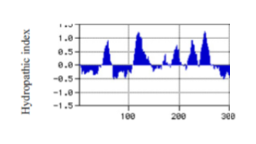
A) The protein is likely an integral membrane protein with multiple transmembrane domains.
B) The protein is likely a soluble cytoplasmic protein with no transmembrane regions.
C) The protein likely has a single hydrophobic segment, indicating it may be anchored to the membrane but not fully spanning it.
D) The protein is likely a peripheral membrane protein with hydrophilic regions facing the aqueous environment.

5) In a thin-layer chromatography (TLC) experiment, a mixture of three lipids is separated on a silica gel plate using a nonpolar solvent. The lipids are: phosphatidic acid, triglyceride, and diacylglycerol. Predict the order of migration (from the origin to the solvent front) and justify your answer.

A) Diacylglycerol > Triglyceride > Phosphatidic acid
B) Phosphatidic acid > Diacylglycerol > Triglyceride
C) Triglyceride > Diacylglycerol > Phosphatidic acid
D) Diacylglycerol > Phosphatidic acid > Triglyceride

6) Integral membrane proteins are proteins that:

a) Loosely associate with the membrane.
b) Can be released from the membrane by slightly changing the pH.
c) Can be released from the membrane by slightly changing the ionic strength of the solution.
d) Penetrate or span the membrane.

7) In the hydrophobic environment of a membrane, the α-helix of a protein folds such that the outer surfaces contain mostly _________________ amino acids, while _________________ amino acids are mostly buried on the inside.

a) Non-polar; Hydrophobic.
b) Polar; Hydrophilic.
c) Hydrophobic; Non-polar.
d) Polar; Hydrophobic.
e) Non-polar; Hydrophilic.
8) Which of these is a general feature of the lipid bilayer in all biological membranes?

A) Individual lipid molecules are free to diffuse laterally in the surface of the bilayer.
B) Individual lipid molecules in one face (monolayer) of the bilayer readily diffuse (flip-flop) to the other monolayer.
C) Polar, but uncharged, compounds readily diffuse across the bilayer.
D) The bilayer is stabilized by covalent bonds between neighboring phospholipid molecules.
E) The polar head groups face inward toward the inside of the bilayer.

9) The fluidity of a lipid bilayer will be increased by:

A) decreasing the number of unsaturated fatty acids.
B) decreasing the temperature.
C) increasing the length of the alkyl chains.
D) increasing the temperature.
E) substituting 18:0 (stearic acid) in place of 18:2 (linoleic acid).

10) The type of membrane transport that uses ion gradients as the energy source to move substances against their concentration gradient is called

A) facilitated diffusion
B) passive transport.
C) primary active transport.
D) secondary active transport.
E) simple diffusion.

11) Which one of the following is true of the pentoses found in nucleic acids?

- C-5 and C-1 of the pentose are joined to phosphate groups.
- The pentoses are in a planar configuration.
- The bond that joins nitrogenous bases to pentoses is an O-glycosidic bond.
- The pentoses are always in the β-furanose forms.
- The straight-chain and ring forms undergo constant interconversion.

12) The phosphodiester bonds that link adjacent nucleotides in both RNA and DNA:

A) always link A with T and G with C.
B) are susceptible to alkaline hydrolysis.
C) are uncharged at neutral pH.
D) form between the planar rings of adjacent bases.
E) join the 3' hydroxyl of one nucleotide to the 5' hydroxyl of the next.

13) For the oligoribonucleotide pACGUAC:

- the nucleotide at the 3' end has a phosphate at its 3' hydroxyl.
- the nucleotide at the 3' end is a purine.
- the nucleotide at the 5' end has a 5' hydroxyl.
- the nucleotide at the 5' end has a phosphate on its 5' hydroxyl.
- the nucleotide at the 5' end is a pyrimidine.

14) Which of these fragments will come from an exonuclease (type a starting at the 3’end with no base specificity) action on the oligonucleotide below?

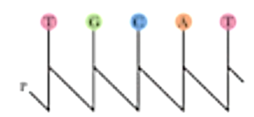

A) T, pGCAT
B) pTGCA, pT
C) pTGCAp, T
D) Tp, GCAT

15) In the Watson-Crick model of DNA structure (now called B-form DNA):

A) a purine in one strand always hydrogen bonds with a purine in the other strand.
B) A–T pairs share three hydrogen bonds.
C) G–C pairs share two hydrogen bonds.
D) the 5' ends of both strands are at one end of the helix.
E) the bases occupy the interior of the helix.

16) Which of the following is a palindromic sequence?

- AGGTCC
TCCAGG
- CCTTCC
GCAAGG
- GAATCC
CTTAGG
- GGATCC
CCTAGG
- GTATCC
CATAGG

17) Which of the following DNA sequences would have the highest melting point (Tm)?

A) ATATATATAT (10 base pairs)
B) GCATGCATGCAT (12 base pairs)
C) ATATAT (6 base pairs)
D) GCGCGCGCGCGC (12 base pairs)

18) Eicosanoids have essential signaling roles; they are the biological oxidation products of arachidonic acid (20:4^{Δ5,8,11,14}). In order to generate eicosanoids, arachidonic acid has first to be released from glycerophospholipids in the membrane. In order to release free arachidonic acid from glycerophospholipids, which enzyme should be activated?

A) Lipase
B) Phospholipase A1
C) Phospholipase A2
D) Phospholipase C
E) Phospholipase D

19) Which of the following statements is correct?

A) Uncatalyzed flip-flop diffusion of phospholipids is fast
B) Glycerophospholipids are amphipathic and form micelles and bilayers in aqueous solution
C) Membrane proteins always have a region inserted into the membrane
D) Carbohydrates are a major component of biological membranes
E) The inner and outer leaflets of the plasma membrane differ in composition

20) Cytosine and ribose form:

A) CMP
B) dCMP
C) Cytidine
D) Deoxycytidine
E) Guanosine

B) Short Answers section. 6 points each. 3 minutes each

1) The fatty acid composition of coconut oil is shown below:
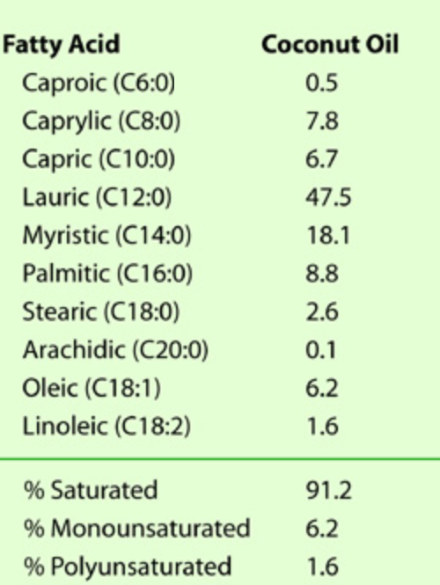

Deep frying is a cooking method in which food is submerged in hot fat. Coconut oil is often considered one of the most suitable oils for deep-frying due to its high resistance to one-electron oxidation at elevated temperatures.
(a) Illustrate the reaction mechanism for the one-electron oxidation of a generic fatty acid. Provide the chemical structures of both the substrate (fatty acid) and resulting product(s). Be sure to include any radical intermediates formed during the reaction, if applicable.

(b) Explain why coconut oil demonstrates high stability against one-electron oxidation. Your answer should be well-structured, logical, and comprehensive. Include relevant chemical reactions to support your explanation and provide the structures of key reactants and products as needed to illustrate your points.

2) Read the abstract below:
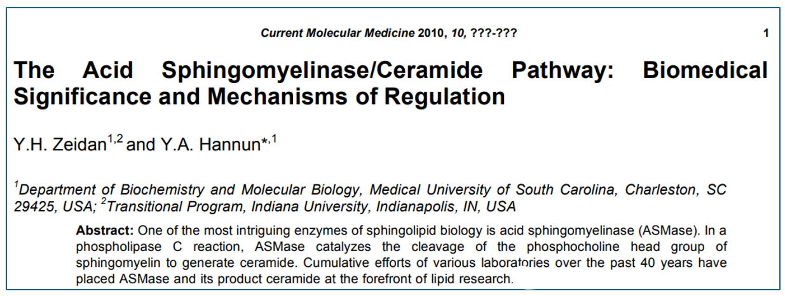
Draw the complete reaction catalyzed by the enzyme acid sphingomyelinase, including the structures and names of substrates and products.

3) Match each of the fatty acids with the appropriate melting point:

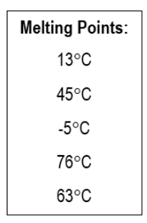

a) CH₃(CH₂)₁₈COOH ______
b) CH₃(CH₂)₁₄COOH ______
c) CH₃(CH₂)₁₀COOH ______
d) CH₃(CH₂)₇CH=CH(CH₂)₇COOH ______
e) CH₃(CH₂)₄CH=CH-CH₂-CH=CH(CH₂)₇COOH ______
4) One of Santa Cruz Biotechnology (SCBT)’s products is pepstatin A (sc-45036), an inhibitor of HIV-1 and aspartic proteases, which is useful for studying protease mechanisms. According to SCBT, “pepstatin A is not cell permeable. We recommend sc-222147, Pepstatin A Methyl Ester, as a cell-permeable alternative.” Why is pepstatin A methyl ester cell-permeable, while pepstatin A is not? Provide a complete answer.
Pepstatin A:
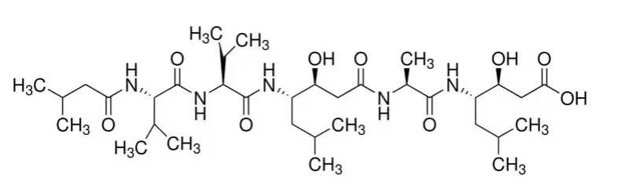
Pepstatin A methyl ester:
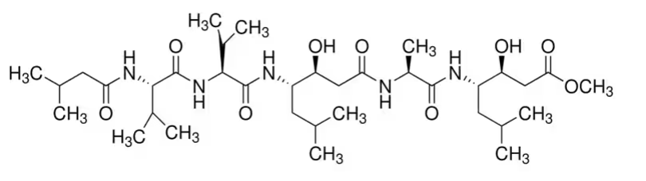

5) Imagine that you perform a series of experiments to test the rate of glucose transport (V₀) into epithelial cells using the Na⁺-Glucose symporters. These experimental epithelial cells contain no intracellular Na⁺ but have the same glucose concentration as their surroundings. In experiment #1, you transfer your cells to test tubes that contain different extracellular [Na⁺] and then measure the rate of glucose transport (V₀). In experiment #2, you introduce leakage Na+ channels (Na+ channels that are typically always open) into the cell membranes and then repeat the same experiment. Label the data on the plot below as showing results to either Experiment #1 or Experiment #2.

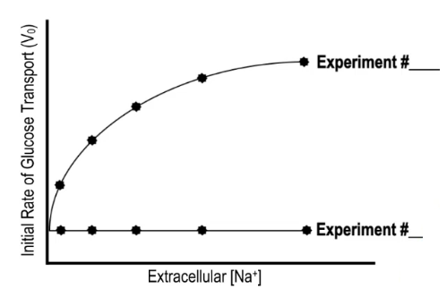

6) The ends of chromosomes (telomeres) consist of highly repeated G-rich sequences. In humans the sequence is (GGGTTA)n where n is several hundred. It is known that G-rich sequences such as telomeres can fold into quadruplexes (see figure below). These structures form slowly, but are extremely stable, with high melting temperatures.

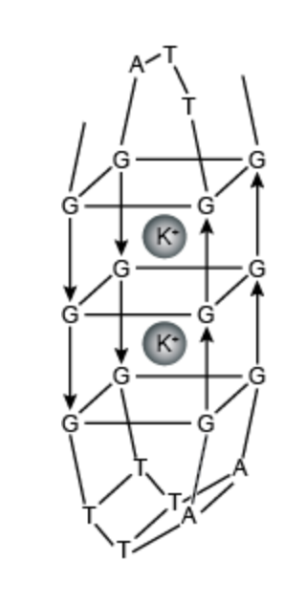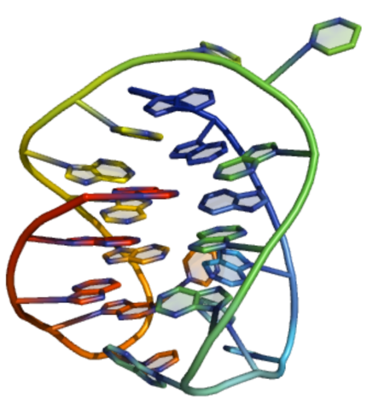

Figure: Three-dimensional structure of a G-quadruplex

Quadruplexes consist of stacks of G-quartets, formed by the association of four G-rich DNA strands and stabilized by metal ions (M⁺, commonly potassium, but occasionally sodium) (see figure below).

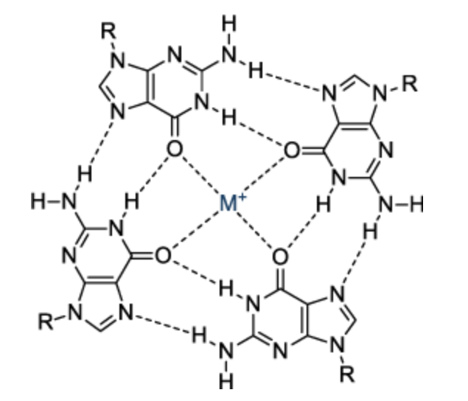

Figure: Bonding in the G-quartet.

Identify (with arrows) all the hydrogen bonds in a G-quadruplex. In each hydrogen bond, identify (with a circle) the hydrogen bond acceptor.

7) The human immunodeficiency virus (HIV) reverse transcriptase enzyme has a ribonuclease catalytic domain called ribonuclease H. Ribonuclease H is an endoribonuclease activity that catalyzes the cleavage of internal phosphodiester bonds in RNA. It has been recently proposed as a target for antiviral drugs. The catalytic mechanism of the ribonuclease H activity of the enzyme reverse transcriptase is proposed below (AIDS Rev. 2002 Oct;4(4):183-194):
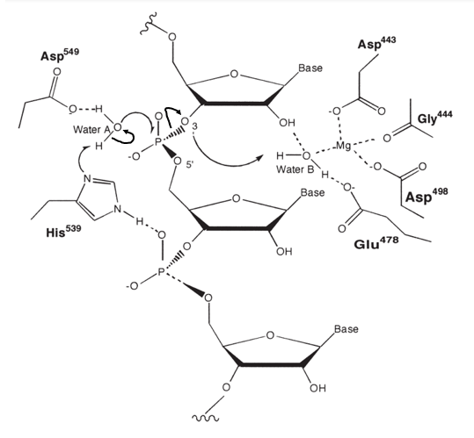
Curly arrows show the movement of electron pairs. Clearly circle and identify the nucleophile, the electrophile and the leaving group in this nucleophilic substitution. Note that the role of His⁵³⁹ and Water B is only in acid-base catalysis.
8) The structure of a single stranded nucleic acid is shown below.

a) Label the following items on the structure using the Roman numeral and an arrow that clearly points to the item.
i) 5’ end.
ii) 3’ end.
iii) A ribose.
iv) A phosphodiester bond.
v) A purine.
vi) A glycosidic bond.

b) Add all missing charges.

